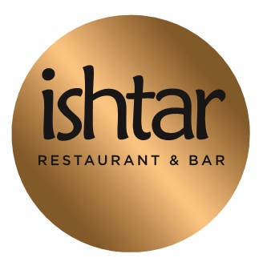

LUNCH & EARLY EVENING MENU
12 NOON- 6 PM
-------
2 Courses £ 24
3 Courses £ 28
- Grilled king prawns in lemon, garlic & ginger sauce
- Pastry filled with spinach & feta cheese
- Mix mezze platter
- Chicken liver Sauteed in herbs
- Grilled Goat cheese, beetroot, walnut salad
- Grilled meat balls with potatoes salad
- Falafel fava beans and chickpeas vegetables frites

-----

- Grilled chicken on skewers
- Braised lamb with pears & apricots served with couscous
- Courgette, spinach, blue cheese radiator shape pasta
- Grilled baby chicken (Poussin) saffron sauce
- Grilled Salmon served with vegetables
- Grilled minced lamb kofta on skewers
- House specialty burger with hand cut chips

----

- Rice pudding
- Apple pie
- Baklava

Our food may contain traces of nuts and other allergens.
If you have any concerns, please ask a member of staff before making your order.
A discretionary optional gratuity of % 12.5 will be added to your total bill.

